You can check your Solution here: https://judge.softuni.bg/Contests#!/List/ByCategory/102/Data-Structures-Exercises

C# Tutorial

Create our Project

When you have skeleton, just run it and skip what version is your project and next steps

The “Judge” works with a version .NET Framework 4.6.1 or older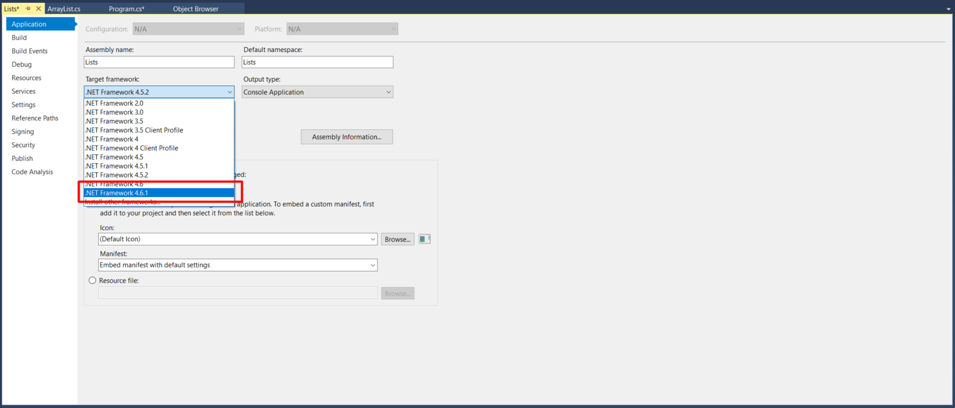
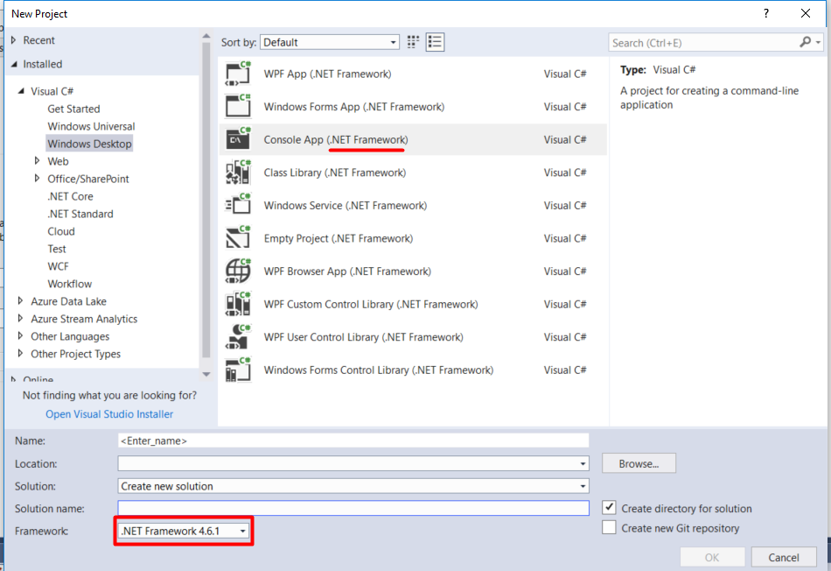

In this case we create new Class “ArrayList”
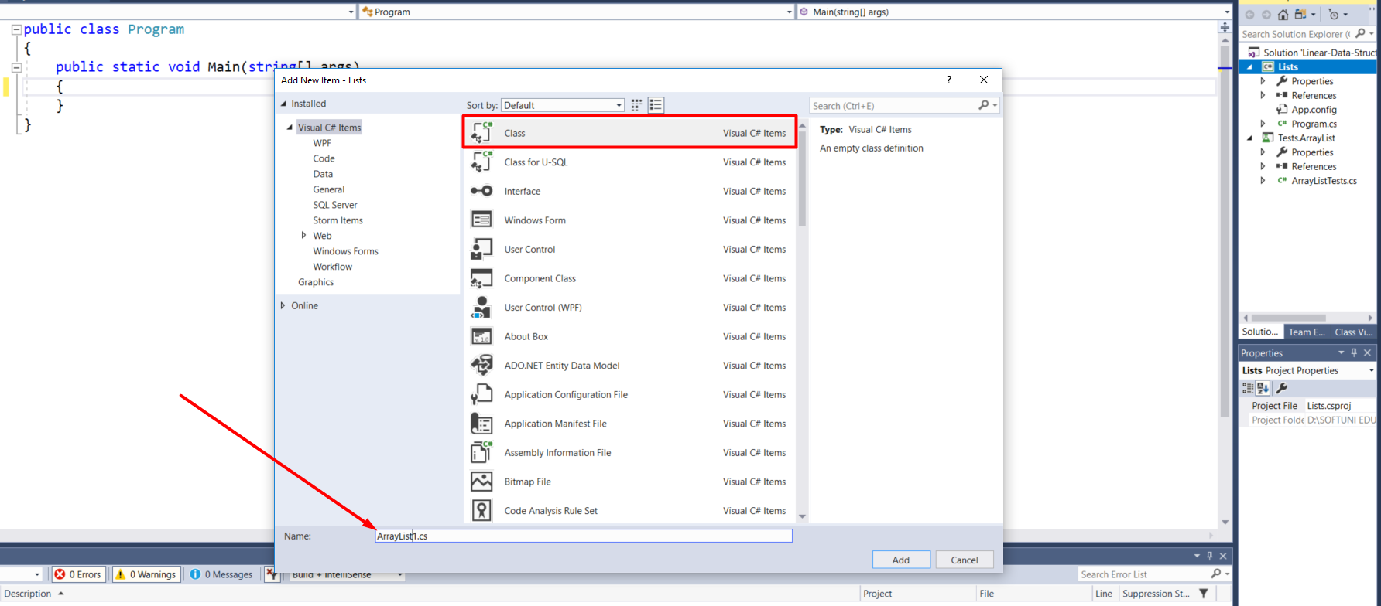
Then, we remove namespaces from the class and make our class public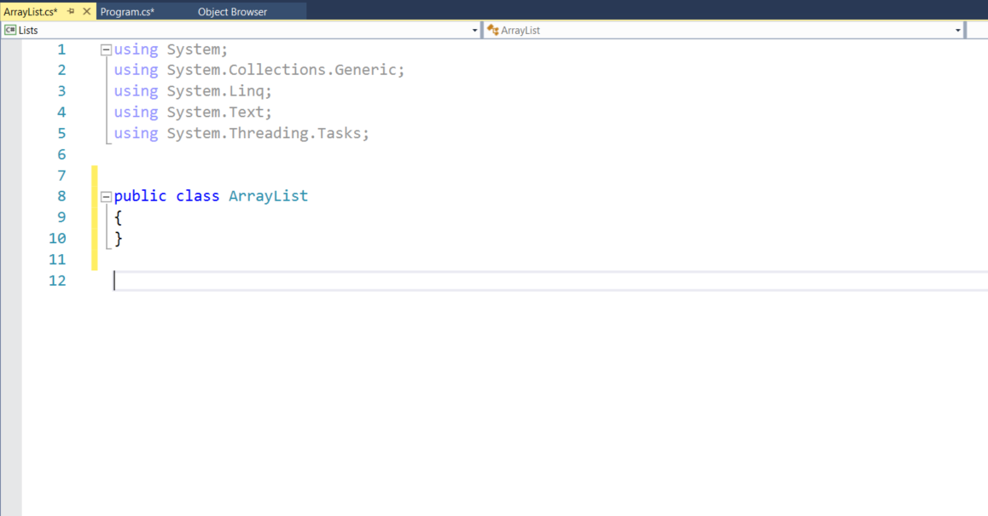Then, we write our class
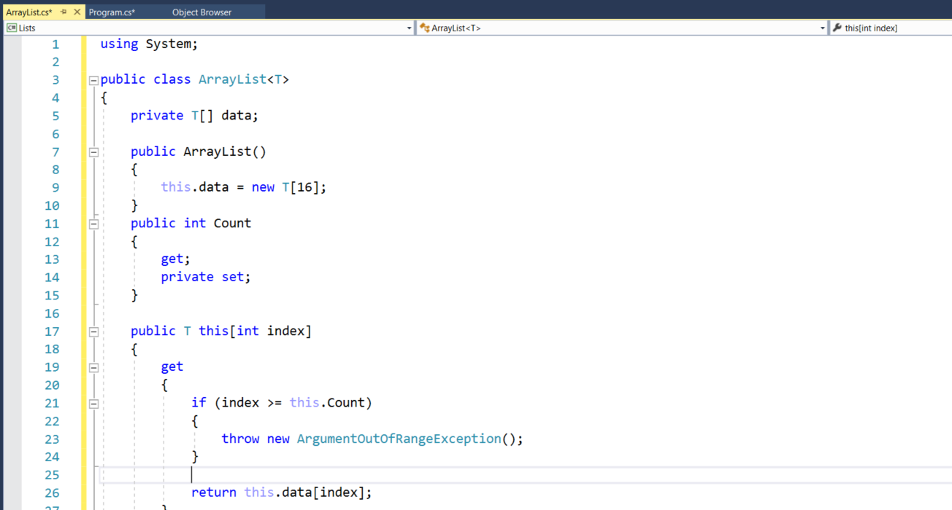

Upload our Project in “Judge”

Save our project and go to your project solution
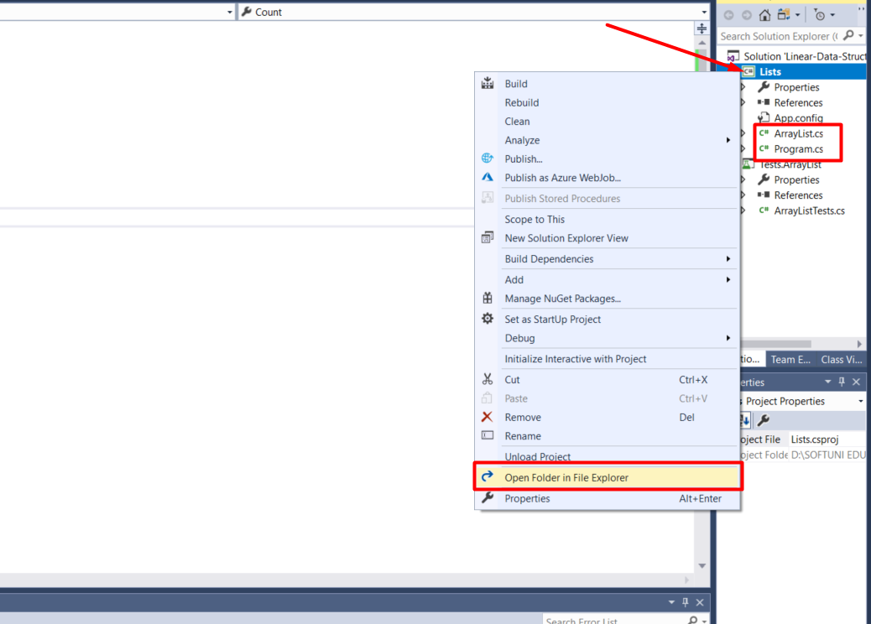

Select all without “bin” and “obj” folders, then compressed it to ZIP
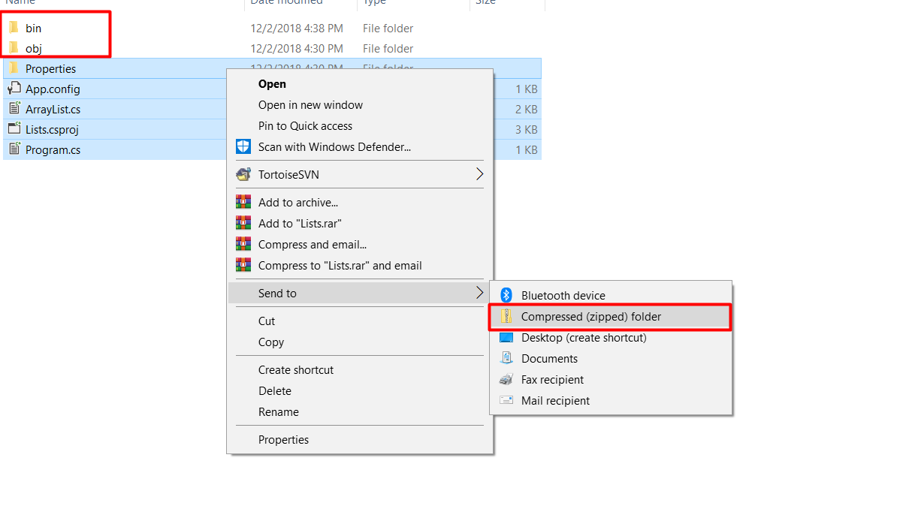

Finally, we can submit our project(ZIP) in "Judge" 